Iacsd@iacsd-virtualbox: ~$ cd

Iacsd@iacsd-virtualbox: ~$ sudo -s

root@iacsd-Virtualbox:/home/iacsd# addgroup threeidiots

//gid 1001

root@iacsd-Virtualbox:/home/iacsd# adduser virus - -gid 1001

root@iacsd-Virtualbox:/home/iacsd# adduser chatur - -gid 1001

root@iacsd-Virtualbox:/home/iacsd# adduser rancho - -gid 1001

root@iacsd-Virtualbox:/home/iacsd# cd ..

root@iacsd-Virtualbox:/home# ls -l

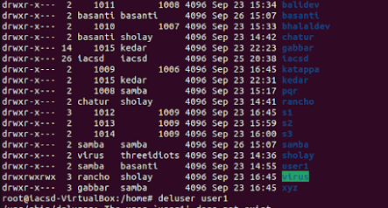

root@iacsd-Virtualbox:/home# ls



root@iacsd-Virtualbox:/home# mkdir EVERYONE

root@iacsd-Virtualbox:/home# chmod 777 EVERYONE

root@iacsd-Virtualbox:/home# ls -l

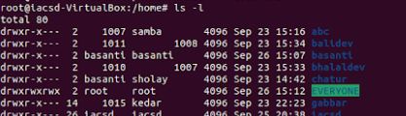

root@iacsd-Virtualbox:/home# su virus

virus@iacsd-Virtualbox:/$ cd home/virus

virus@iacsd-Virtualbox:~$ touch virus.txt

virus@iacsd-Virtualbox:~$ ls

virus@iacsd-Virtualbox:~$ mv virus.txt /home/EVERYONE

virus@iacsd-Virtualbox:~$ ls

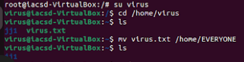

virus@iacsd-Virtualbox:~$ su iacsd or exit

Iacsd@iacsd-virtualbox: ~$ sudo –s

root@iacsd-Virtualbox:/home# cd /home/EVERYONE

root@iacsd-Virtualbox:/home/EVERYONE # ls

**CHANGE THE GROUP**

root@iacsd-Virtualbox:/home/EVERYONE # cd ..

root@iacsd-Virtualbox:/home# addgroup ramayan

//gid 1002

root@iacsd-Virtualbox:/home# adduser ram - -gid 1002

root@iacsd-Virtualbox:/home# adduser laxman - -gid 1002

root@iacsd-Virtualbox:/home# adduser sita - -gid 1002

root@iacsd-Virtualbox:/home # ls

root@iacsd-Virtualbox:/home # ls -l

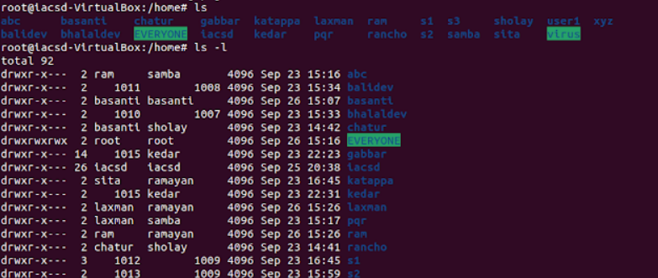

root@iacsd-Virtualbox:/home # cd /home/ram

root@iacsd-Virtualbox:/home/ram# mkdir demo

root@iacsd-Virtualbox: /home/ram# cd /home/ram/demo

root@iacsd-Virtualbox: /home/ram/demo# touch file.txt

root@iacsd-Virtualbox: /home/ram/demo# ls



root@iacsd-Virtualbox: /home/ram/demo# chmod 777 file.txt

root@iacsd-Virtualbox: /home/ram/demo# chgrp threeidiots file.txt

root@iacsd-Virtualbox: /home/ram/demo# cd ..

root@iacsd-Virtualbox: /home/ram# cd ..

root@iacsd-Virtualbox: /home# ls –l

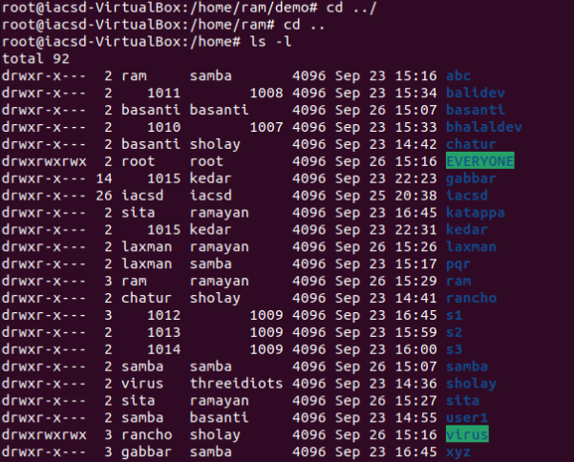

root@iacsd-Virtualbox: /home # cd /home/ram/demo

root@iacsd-Virtualbox: /home/ram/demo # ls –l



**To change the owner**

root@iacsd-Virtualbox: /home/ram/demo# chown virus file.txt



root@iacsd-Virtualbox: /home/ram/demo# ls -l



root@iacsd-Virtualbox: /home/ram/demo# cd ..

root@iacsd-Virtualbox: /home/ram#

root@iacsd-Virtualbox: /home# ls -l